Data Flow Diagram
1. Level 1 Data Flow Diagram (DFD)
Data moves from the user interface, validates through WTForms modules, passes to the ML preprocessing pipeline, saves to the SQLite database, and persists to PDF certificates:

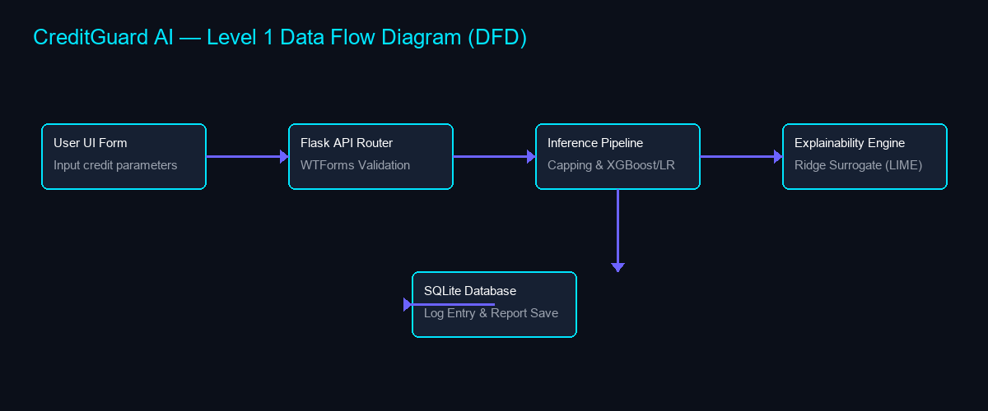
2. Process Definitions
• Process 1.0 (Validation): Sanitizes inputs (DTI, Age, Family Members).
• Process 2.0 (Inference): Applies scaling and caps outliers to match XGBoost/Logistic Regression formats.
• Process 3.0 (Explainability): Runs local surrogate evaluations once per transaction.

